Exercise 4: Creating and Configuring a Maven Project
Scenario: Set up a new Maven project named LibraryManagement for the library management application and configure it with the required Spring dependencies and compiler settings.

What Was Done
• Created a new Maven project named LibraryManagement in IntelliJ IDEA.
• Configured groupId as com.library, artifactId as LibraryManagement, and version as 1.0-SNAPSHOT in pom.xml.
• Added the standard Maven folder structure: src/main/java, src/main/resources, and src/test/java.
• Added Spring dependencies in pom.xml: spring-context, spring-aop, and spring-webmvc, all version 5.3.20.
• Configured the Maven Compiler Plugin in the build section of pom.xml to use Java version 1.8 as both source and target.
• Reloaded the Maven project so all dependencies were downloaded and resolved successfully.
• Verified in the Maven tool window that all three Spring dependencies appear correctly under the Dependencies node of the LibraryManagement project.

Result
The Maven project was created and configured successfully. The pom.xml file contains all required Spring dependencies and the compiler plugin, and the Maven tool window confirms the dependencies were resolved without build errors.

Output Screenshot
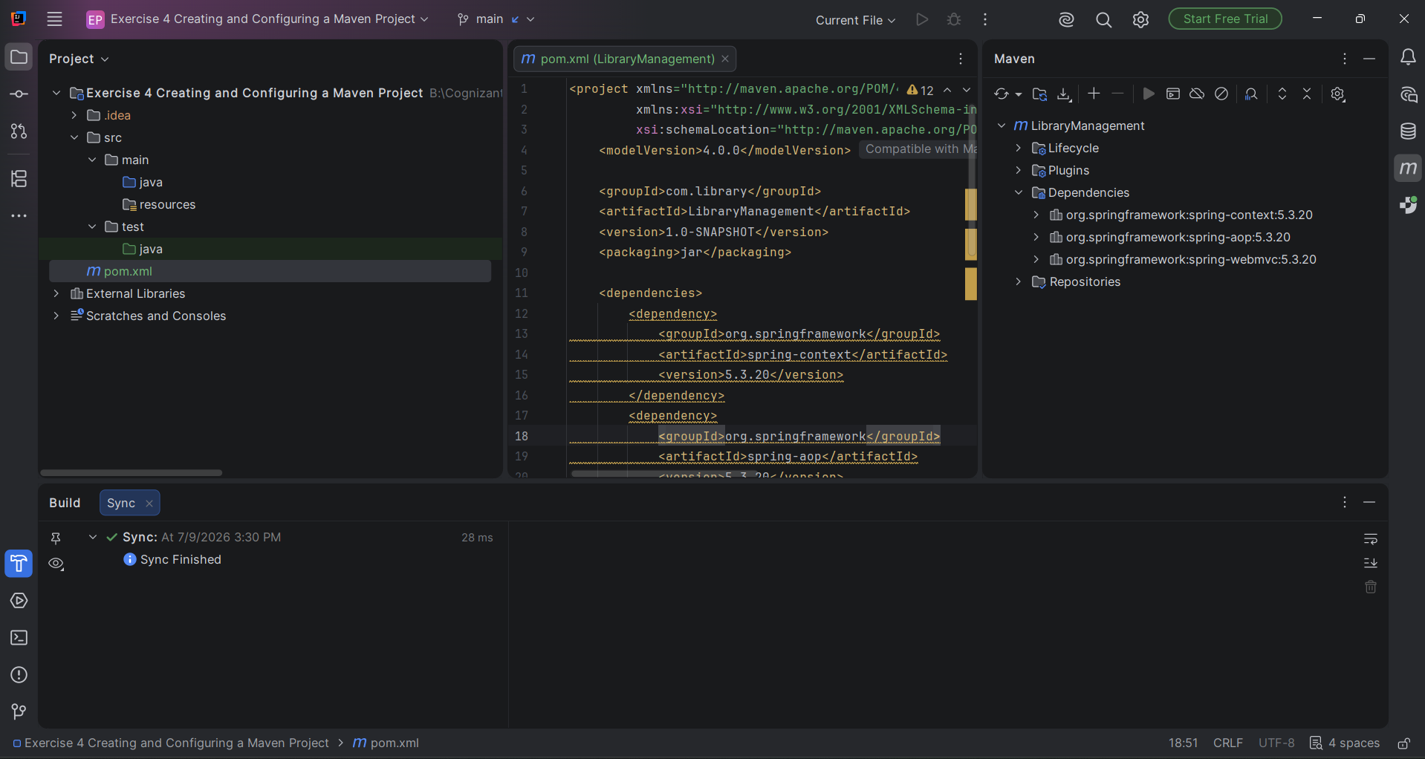
Figure: pom.xml with Spring dependencies resolved and visible in the Maven tool window.

